API – GET Method: https://localhost:7005/api/Employees
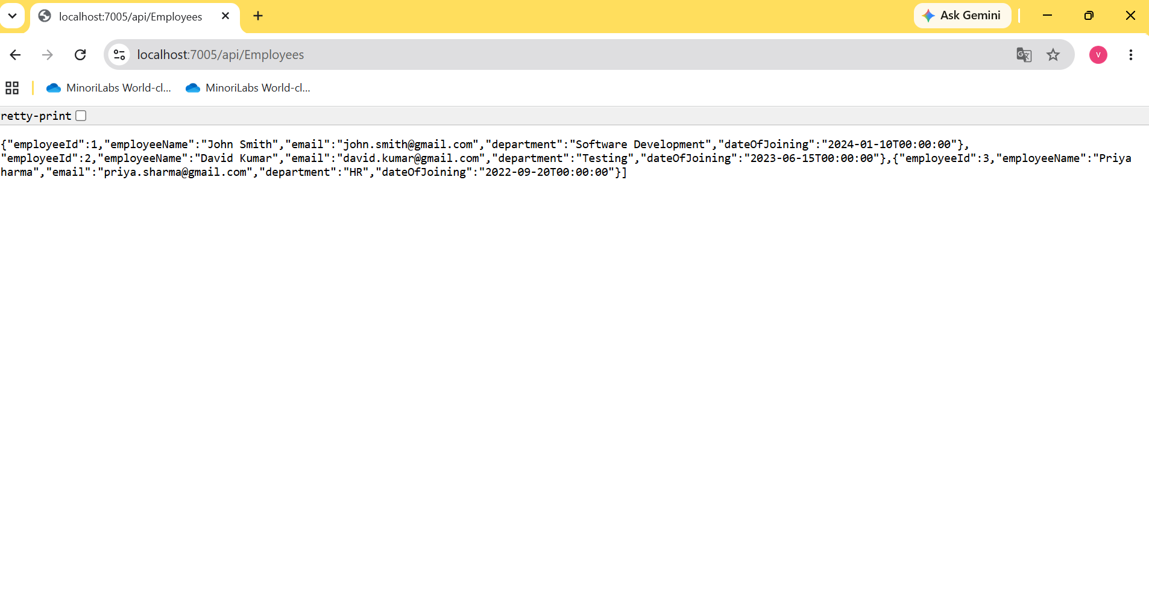

API – POST Method: https://localhost:7005/api/Employees

API – GET by ID https://localhost:7005/api/Employees/1
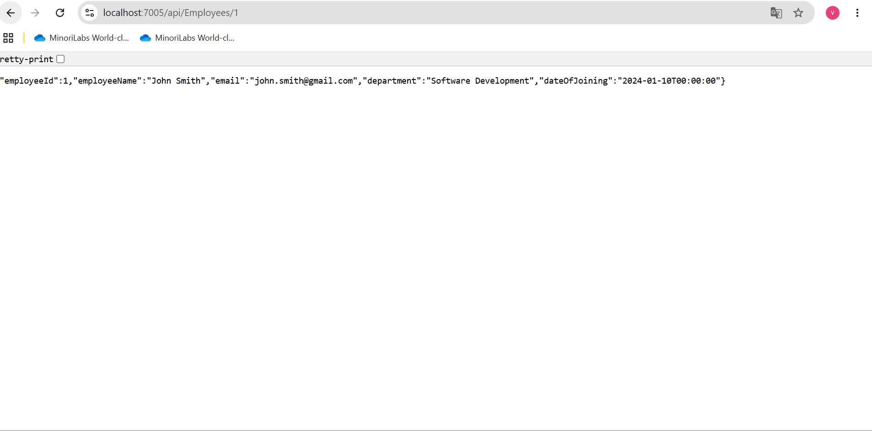

API – PUT - https://localhost:7005/api/Employees/2
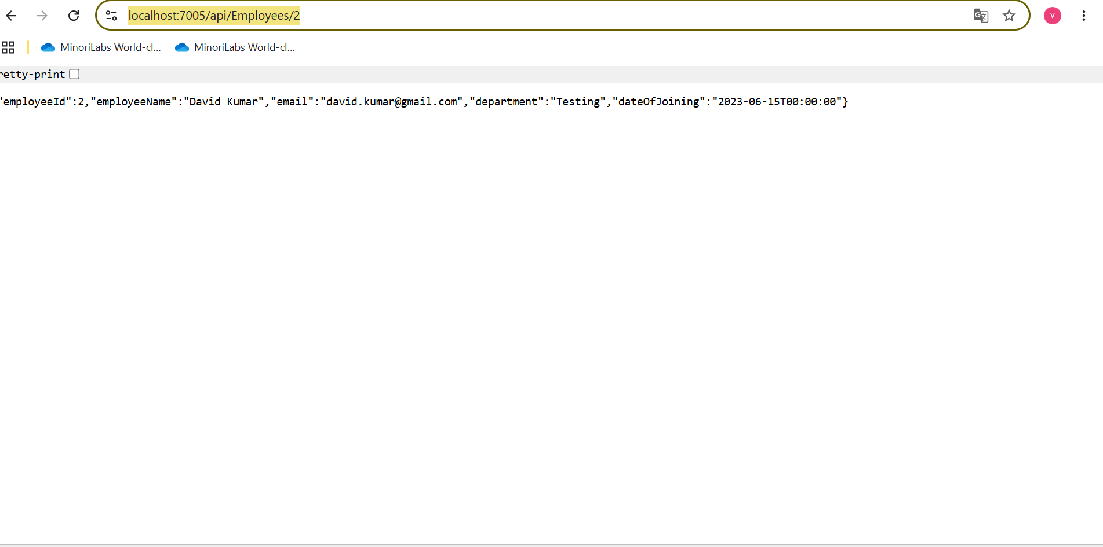

API - DELETE https://localhost:7005/api/Employees/3

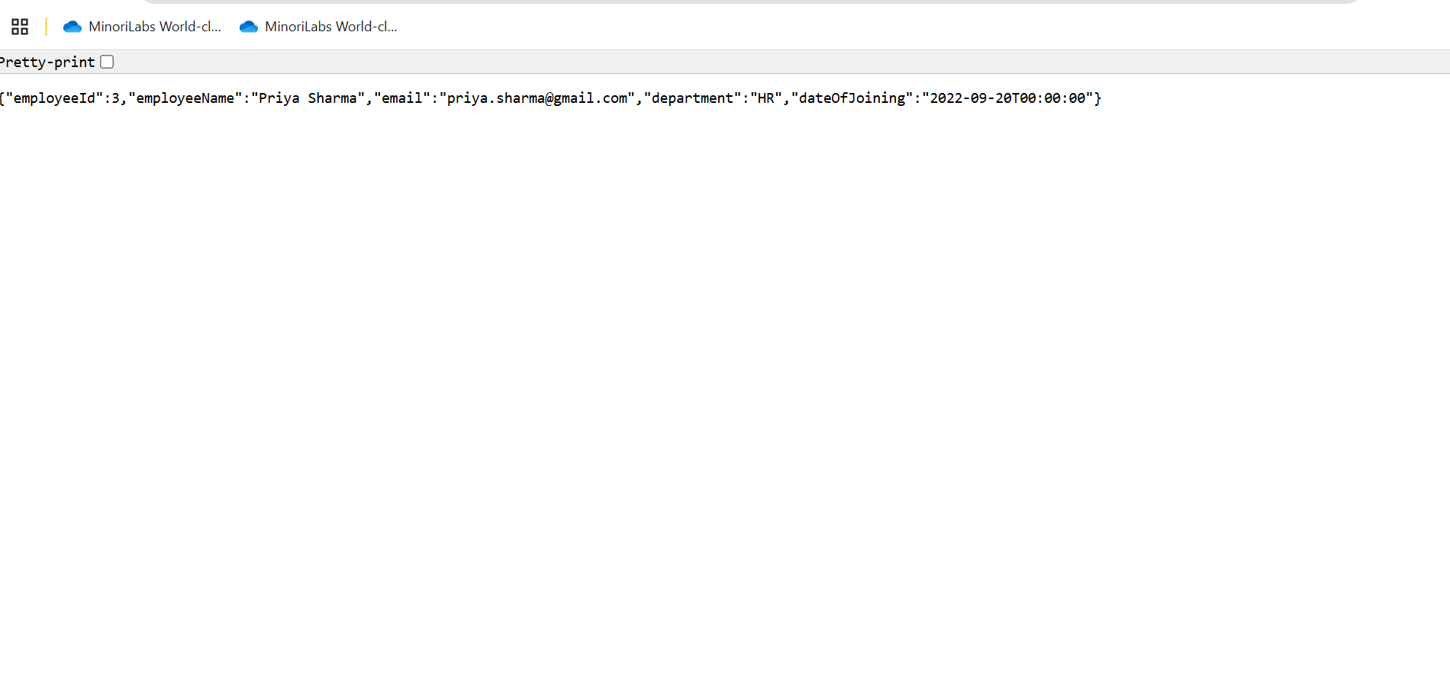
JWT Token
